Rem vs em

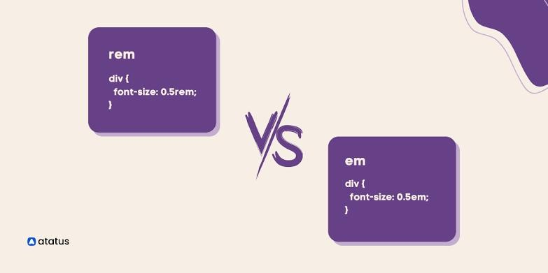

# Rem in CSS

Relative CSS length units are proportional to another value, such as the CSS font size of the parent element or the viewer size. With appropriate modifications, you might design it so that the size of text or more components evolves relative to the rest of the page by employing relative units.

The acronym rem stands for root em. The font size for elements in CSS units is determined by rem CSS units in relation to their root elements. The default CSS font size value for most browsers is 16px, so an element with a value of 1rem will also have a CSS font size of 16px.

The rem units are helpful for scaling CSS elements in relation to the standard CSS font size. A value or data type's length is expressed in rem. Rem is compatible with all properties that take length as a value.

The font size of the root element's rem reclaims its values. Consequently, 1rem acknowledges the very same value throughout your entire CSS code.

## Em in CSS

The CSS unit em has the same value as the parent element's determined font size. For instance, if a div element has font: 16px; specified, 1em will be 16px for both the div and any children of the div.

When utilizing em in your project, it is recommended that you avoid explicitly defining font-size anywhere other than the root element. Using em CSS units effectively enables versatility in the sizes of different components while enhancing layout across the entire page.

The font size of an element in relation to its parent may be changed using the em unit. It thus manages to make it simple to sustain the size correlation amongst elements in a responsive design.

Em manages further with layouts that demands submenu items to successively decline in font size, such as sidebar menu. It is possible to automatically scale the size of every child element in accordance with the parent size.